UML Diagrams

UML Use Case Diagram

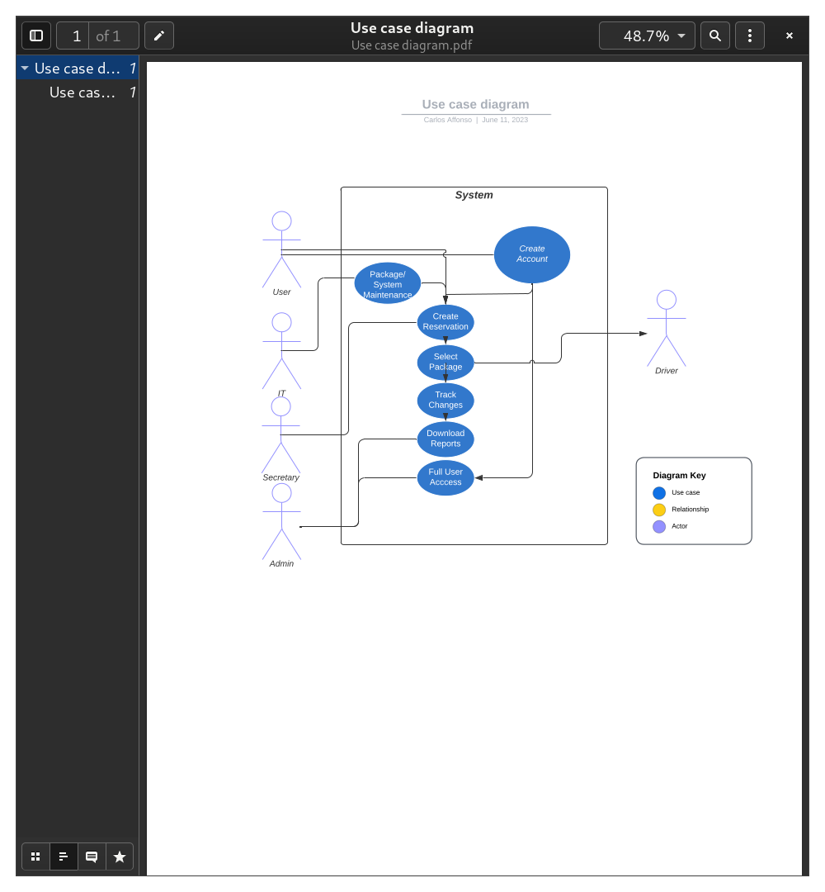

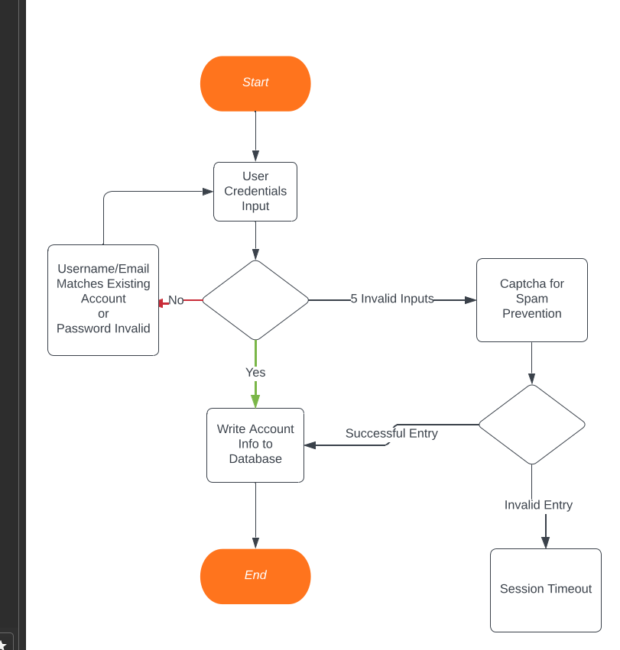
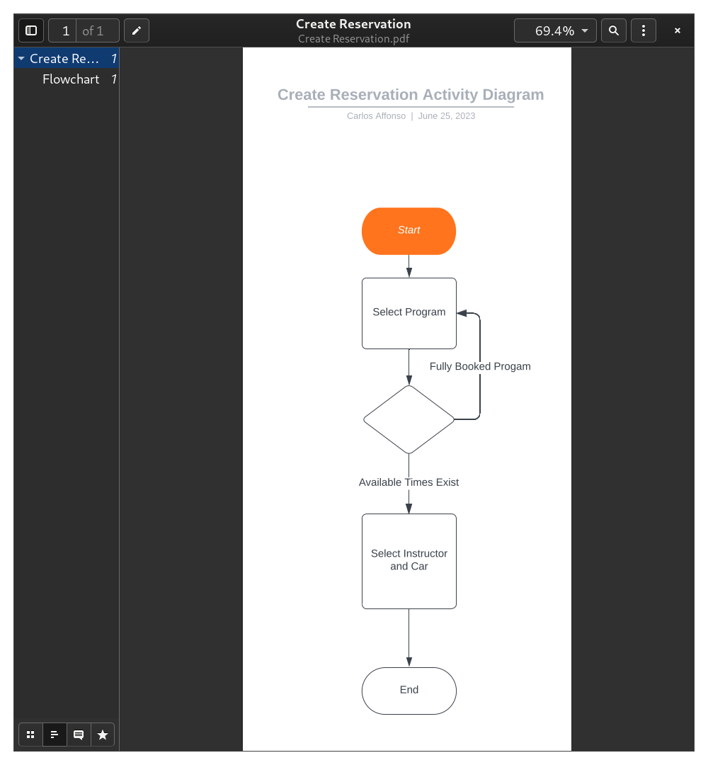
UML Activity Diagrams

UML Sequence Diagram
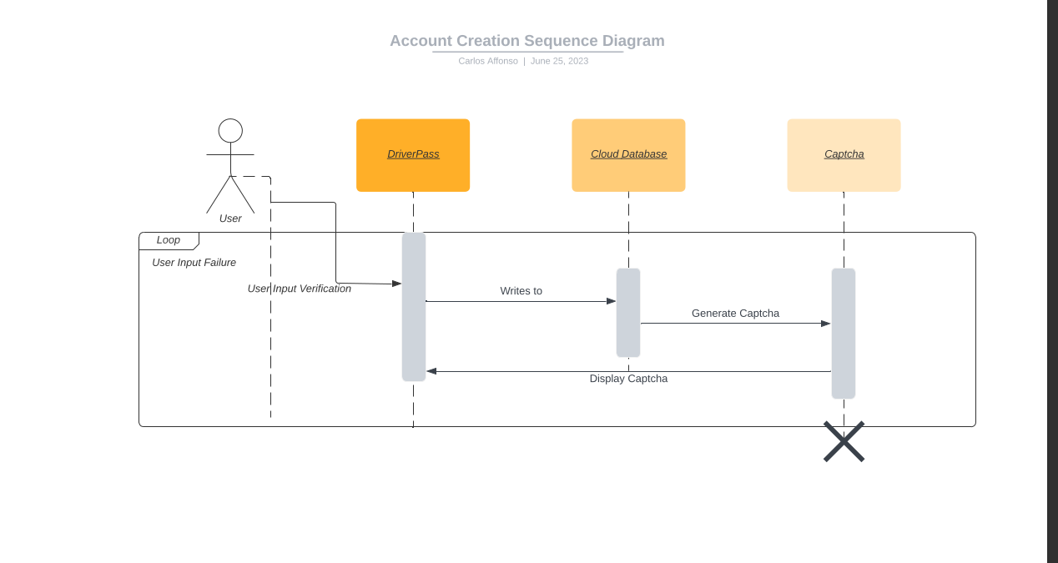

UML Class Diagram
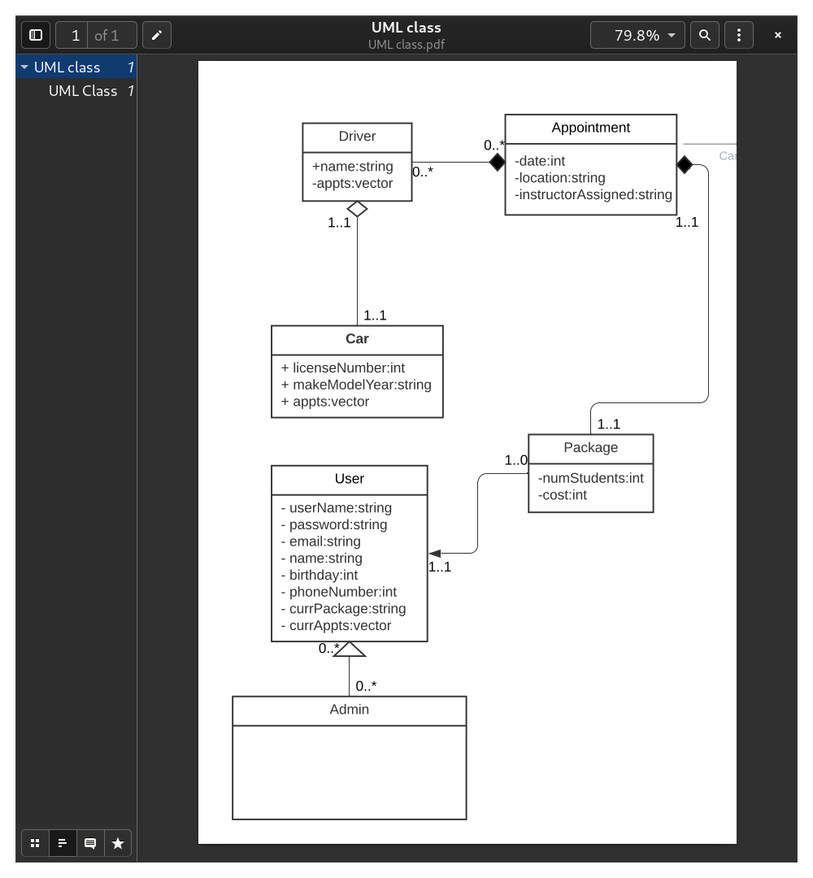

Technical Requirements
DriverPass has requested that their databases be hosted through the cloud. DriverPass has some options in these regards, such as AWS, Azure or even Google Cloud. Using this option, DriverPass trades having to maintain a physical server so they can have the convenience of not having to deal with such. Concerning software, JavaScript continues to be a popular option for web based programs and it would be able to handle all cases that DriverPass would pass through it.

